Visual Voices of Homeless Women on the Danube Promenade in Budapest
What does safety mean to us? A home where we can close the door behind us? A person we can rely on? An object connected to an important memory? Or simply the feeling that we can decide what happens to us?
These were the questions at the heart of Visual Voices, an outdoor exhibition organised by BMSZKI in cooperation with the Budapest Cultural Centre on the Danube Promenade between 25 August and 6 September 2026. The exhibition featured 44 photographs and the personal stories behind them, created by women who have experienced homelessness to show what safety means to them.
The original aim of the Visual Voices project was primarily to bring the experiences of the participating women to professionals working in homeless services, community-based social services and services supporting victims of violence against women. However, the photographs and stories collected during the project raised such powerful questions – many of them familiar to all of us – that BMSZKI decided to share some of them with a wider public as well.
The Promenade by the Danube proved to be a particularly good location for this. Closed to car traffic in the evenings and at weekends, it becomes a casual space for pedestrians, cyclists, Budapest residents and tourists. Thousands of people pass by the exhibition every single day. At the official opening, participants were welcomed by the Mayor of Budapest and the leaders of the organisations involved in the project.
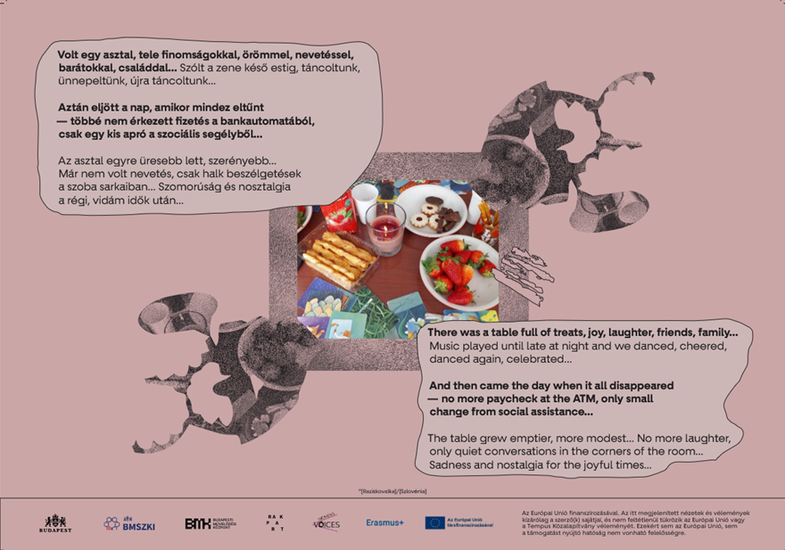
More Than Just Looking
Over the two weeks, the exhibition was accompanied by creative activities on four afternoons involving peers – women who have experienced what it is like to be without a home. The aim was to encourage visitors not only to encounter other people’s stories about safety, but also to take a moment to look at their own lives from this perspective.
Participants could choose from more than a hundred objects of different shapes and sizes. We looked for things that could in some way be connected to the experience of feeling that everything is all right: that I have a say in what happens to me and that I am able to have control over my own life.
Visitors could use these objects to create their own installations, sometimes inspired by the photographs in the exhibition, and then take pictures of their compositions using a photo booth. Many people who initially stopped because of the playful and creative activity went on to look through the entire exhibition. Perhaps they continued on their way with a little more knowledge – and a few new questions – than they had arrived with.
Wounds, Exclusion, Home and Hope
When selecting the photographs for the exhibition, an important consideration was that they should not only be meaningful to people working in homeless services. We looked for stories that could bring the lives of women who have experienced homelessness closer to people who have no personal connection to this world.
The photographs were organised around four main themes: wounds of the past; life on the streets and exclusion; homeless shelters through women’s eyes; and hope and housing.
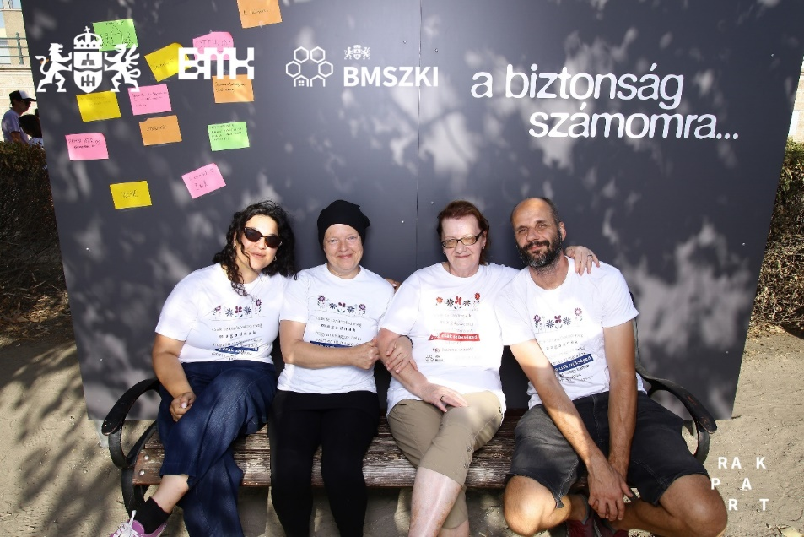

A Home Is More Than a Roof
The photographs about hope and housing perhaps raise one of the most important questions of the exhibition: what does a person lose when they lose their home?
It is not simply a flat or a room. Losing one’s housing can weaken relationships with family and friends, personal belongings may be lost, and roles that once seemed a natural part of everyday life can disappear. Feelings of rejection and shame may also emerge, making it even more difficult to ask for help.
This is why homelessness cannot be addressed simply by creating more shelter places. Shelters can provide essential support in a crisis, but on their own they do not solve the problem of housing.
We also need forms of support and affordable housing opportunities that offer people on low incomes a genuine chance to have a home of their own.
Because leaving homelessness behind does not simply mean having somewhere to sleep again. It means having a space of one’s own, independence, stability and the feeling of once again having a say in one’s own life. In other words: safety and hope.

Tamás Gerencsér

